# MicroBit Robot Interface Board

Revision D, 15/05/2016

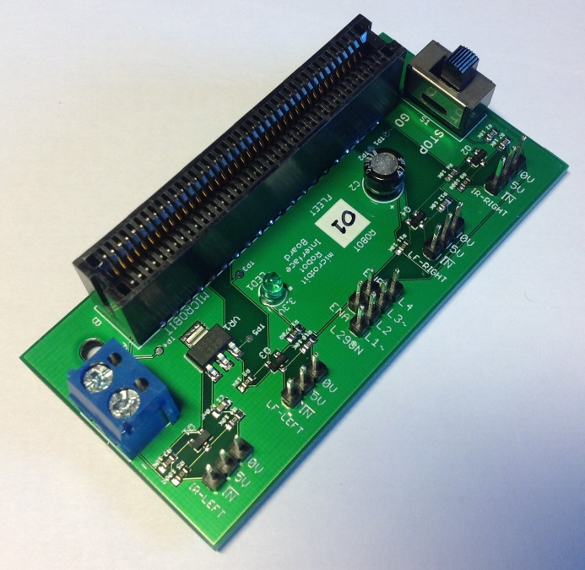

MicroBit Robot Interface Board

## Introduction

The MicroBit Robot Interface Board has been developed to allow the BBC micro:bit educational microcontroller board to be used to control the existing fleet of 4tronix robots used in the Robotics Challenge programme. The robots are currently controlled via Arduino Uno boards, using 5V logic level sensors. The micro:bit is powered at 3.3V, and its IO pins are not 5V tolerant.

The logic level conversion functions of the robot interface board are based heavily on the SparkFun Bi-Directional Logic Level Converter board[1]. The designs for the SparkFun board are released under the Creative Commons Attribution Share-Alike 3.0 licence (CC-BY-SA 3.0). As derivative works the designs for the robot interface board are released under the CC-BY-SA 4.0 licence[2], using the “all later versions” compatibility provisions.

## Description

The MicroBit Robot Interface Board has the following features:

* Four 3-pin input channel connectors for 5V sensors. These are currently used for left and right infra-red obstacle sensors, and left and right infra-red line follower sensors. These connectors deliver 5V to power the sensors, and each 5V input signal line is shifted down via a BSS138 FET to 3.3V for connection to a micro:bit IO pin. The 5V supply is derived directly from the supply to the interface board.
* Current limiting series resistors (R5, R8) are included for the sensor connections which re-use micro:bit “button” pins, to protect the sensor outputs from being shorted to ground in the event that the buttons are pressed while a sensor is connected.
* Four output pins for connection to the L298N H-bridge motor control board. These are connected directly to micro:bit 3.3V outputs, and are not level shifted up to 5V: The data sheet for the L298N indicates that 3.3V is adequate for logic HIGH detection, and testing confirms this.
* Two switched GND/5V pins for connection to the L298N H-bridge enable pins. The switch (labelled STOP/GO) allows the robot motors to be disabled without removing power to the L298N or micro:bit boards. The enable jumpers fitted by default to the L298N board are removed.
* A 3.3V regulated power supply for the micro:bit board, and an indicating LED. This 3.3V supply is derived from the 5V supply to the interface board via a LM3940 voltage regulator.
* A screw terminal power connector for a regulated 5V power feed derived from the 5V voltage regulator on the L298N motor control board (which also provides a 5V logic supply to the L298N bridge controller).
* A 40-way edge connector for the micro:bit board. This is arranged so that micro:bit will be vertical with the LED matrix facing forward.

## Pin Allocations

The interface board connections to the micro:bit connector are listed in the following table.

|  |  |  |  |
| --- | --- | --- | --- |
| **PCB Label** | **Description** | **Micro:bit Software Pin** | **Notes** |
| LF-LEFT | Left Line Follower Sensor | 16 |  |
| LF-RIGHT | Right Line Follower Sensor | 0 | Large Pad |
| IR-LEFT | Left Obstacle Sensor | 11 | BTN B |
| IR-RIGHT | Right Obstacle Sensor | 5 | BTN A |
| L1 | L298N Bridge Controller | 2 | Large Pad, PWM |
| L2 | L298N Bridge Controller | 12 |  |
| L3 | L298N Bridge Controller | 1 | Large Pad, PWM |
| L4 | L298N Bridge Controller | 8 |  |

## Parts List

All part codes are Farnell (<http://uk.farnell.com>) unless otherwise indicated.

Quantities are per interface board. Note that these are component quantities, not minimum order quantity multiples.

|  |  |  |  |
| --- | --- | --- | --- |
| **Reference** | **Description** | **Part Code** | **Quantity** |
| C1 | 470nF 0603 SMD 25V MLCC | 1856365 | 1 |
| C2 | 47uF 2.5mm 25V Electrolytic | 1870939 | 1 |
| R1 | 470R 0603 SMD Resistor | 9332146 | 1 |
| R2, R3, R4, R6, R7, R9, R10, R11, R12 | 10K 0603 SMD Resistor | 9331700 | 9 |
| R5, R8 | 100R 0603 SMD Resistor | 9331689 | 2 |
| Q1, Q2, Q3, Q4 | BSS138 FET (SOT23 Package) | 2053833 | 4 |
| LED1 | 3mm Green LED | 1581123 | 1 |
| VR1 | LM3940 (SOT223 Package) | 1469104 | 1 |
| S1 | Knitter-Switch MFP106D | 807527 | 1 |
| Screw Terminal Block | Multicomp MA522-500M02 | 2396252 | 1 |
| Header Pins | Harwin M20-9992046 0.1” x 20 | 1022262 | 1 |
| Edge Connector | Sullins RBB40DHHN | Digi-Key S3389-ND[3] | 1 |

## PCBs

Eagle and Gerber files for the interface board PCB are available on GitHub[4]. Prototype PCBs were fabricated by OSH Park[5], and production boards by SeeedStudio[6]. Note that the appropriate Gerber files must be used when ordering PCBs.

The OSH Park permalink for Rev C boards is: <https://oshpark.com/shared_projects/VPkVN2p7>.

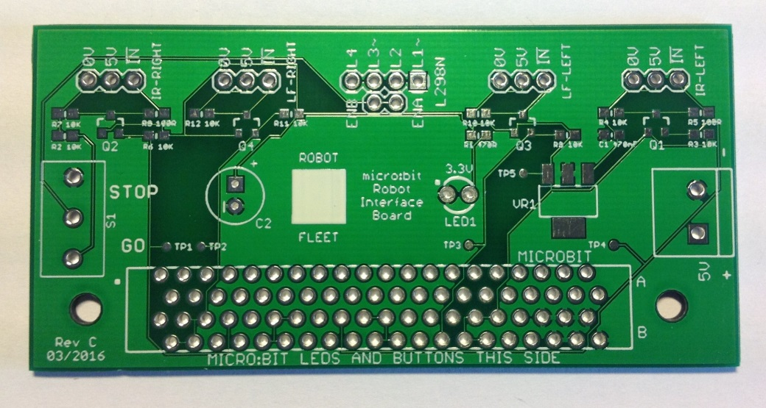

Interface PCB Fabricated by SeeedStudio

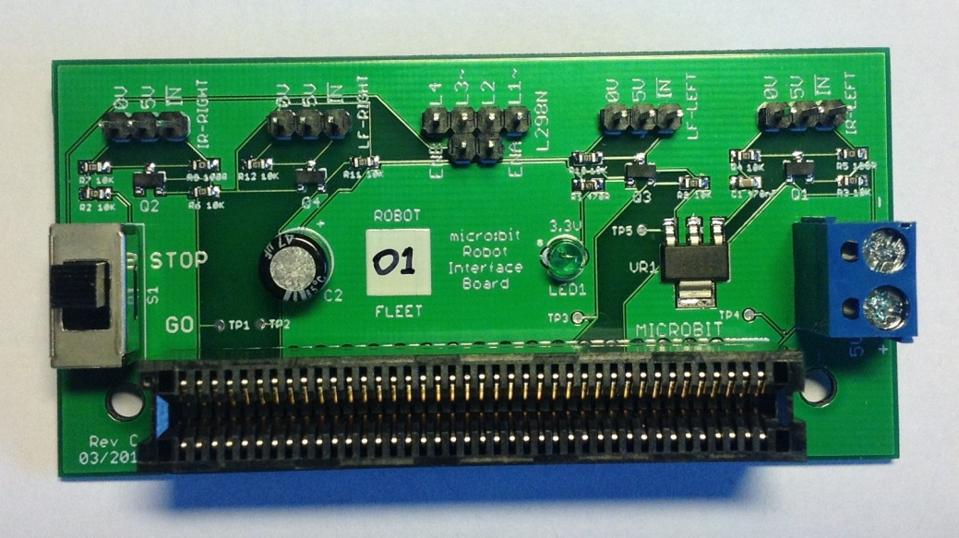

Completed Robot Interface Board

## Wiring Diagrams

### Power Wiring

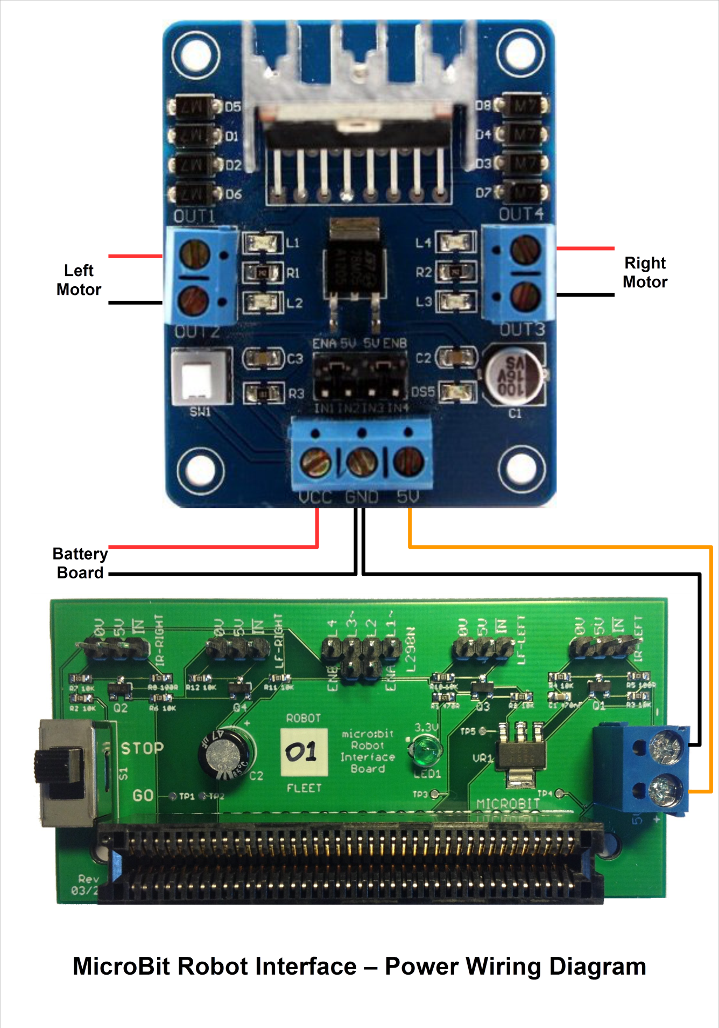

### Control Wiring

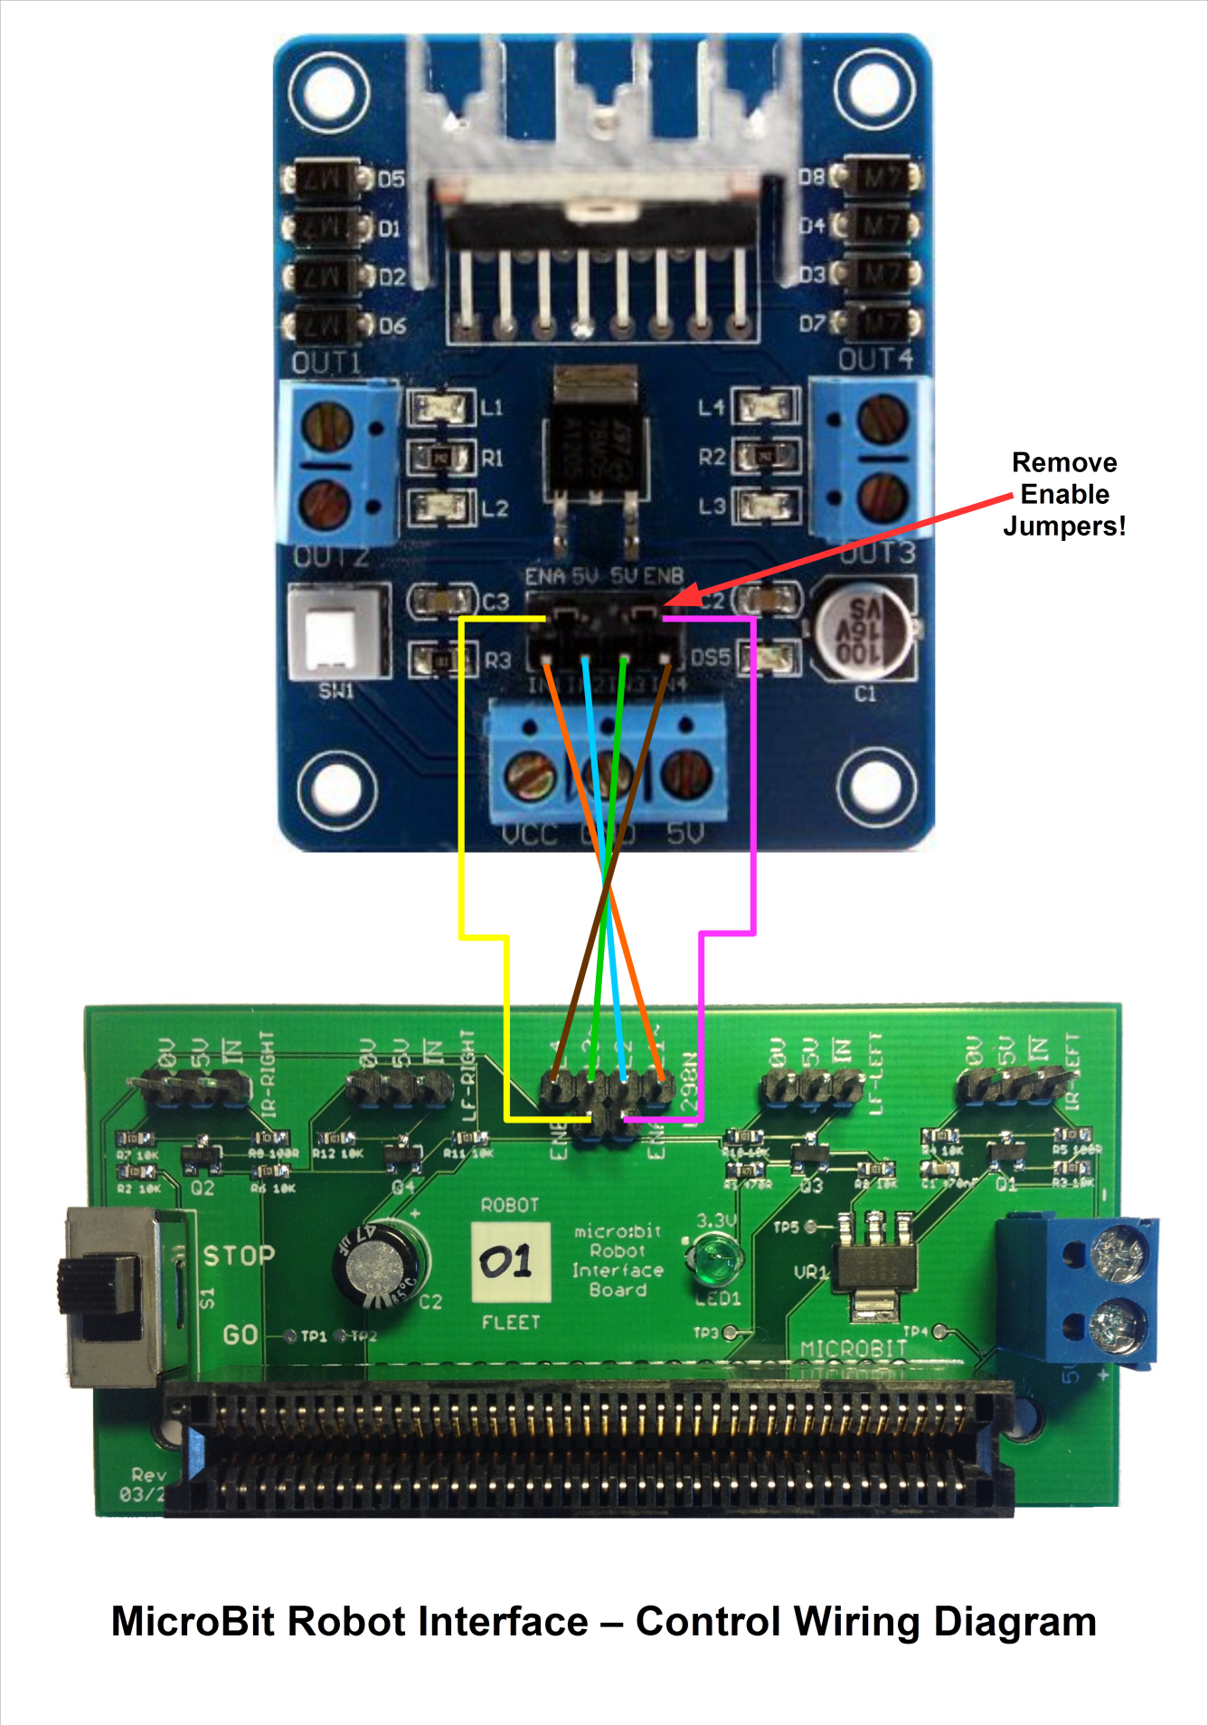

## Change History

|  |  |
| --- | --- |
| **Revision** | **Changes** |
| A | First prototype version. |
| B | Updated the micro:bit custom Eagle library to match final release micro:bit hardware.  Moved Button A from pin 4 to pin 5 to match final release hardware.  Swapped over P1 and P8 on L3 and L4, because P8 does not support PWM.  Relocated the motor enable switch to the edge of the board for better access. |
| C | Fixed the orientation of the motor enable switch.  Added test points on the 3.3V side.  Generated Gerbers for both OSH Park and SeeedStudio.  Added wiring diagrams and board images. |
| D | Increased width of 5V & 3.3V power traces to 16mil throughout. |

## Board Test Procedures

Equipment required:

* 5V regulated power supply (e.g. from an Arduino Uno or L298N board)
* Voltmeter
* Jumper wires
* Voltages should be within approximately ±0.1V of expected.

|  |  |  |  |
| --- | --- | --- | --- |
| **#** | **Procedure** | **Expected Result** | **Interpretation** |
| 1 | Disconnect any cables from the interface board.  Remove the micro:bit from the edge connector.  Set the slide switch to the STOP position. | (Preparation) |  |
| 2 | Connect a regulated 5V supply to the interface board power supply screw terminal block, observing the correct polarity. | Green LED lit. | *This test confirms that the 3.3V voltage regulator is working.* |
| 3 | Measure the supply voltage across the screw terminal block. | +5V. | *This test confirms that the external 5V supply is working.* |
| 4 | Relative to the power supply input –ve terminal, measure the voltage at test point TP5. | +3.3V. | *This test confirms that the 3.3V voltage regulator is working.* |
| 5 | Relative to the power supply input –ve terminal, measure the voltage on the four sensor input pins marked 5V. | All +5V. | *This test confirms that the sensor 5V supply pins are connected to the 5V input supply.* |
| 6 | Relative to the power supply input –ve terminal, measure the voltage on the four sensor input pins marked 0V. | All 0V. | *This test confirms that the sensor 0V supply pins are not shorted to the 5V input supply.* |
| 7 | Relative to the power supply input **+ve** terminal, measure the voltage on the four sensor input pins marked “0V”. | All -5V. | *This test confirms that the sensor 0V supply pins are in fact connected to the 0V input supply.* |
| 8 | Relative to the power supply input –ve terminal, measure the voltage on the four sensor input pins marked IN. | All +5V. | *This test confirms that the sensor input pins are being pulled up to 5V by the resistors R4, R7, R10, R12, and that the MOSFETs Q1, Q2, Q3, Q4 are not conducting.* |
| 9 | Relative to the power supply input –ve terminal, measure the voltage on the four motor output pins L1, L2, L3, L4. | All 0V. | *This test confirms that the motor output pins are not shorted to the 5V input supply.* |
| 10 | Relative to the power supply input **+ve** terminal, measure the voltage on the four motor output pins L1, L2, L3, L4. | All 0V. | *This test confirms that the motor output pins are not shorted to the 0V input supply.* |
| 11 | Relative to the power supply input **+ve** terminal, measure the voltage on the two motor enable pins ENA, ENB. | Both -5V. | *This test confirms that the motor enable pins are connected to 0V when the switch is in the STOP position.* |
| 12 | Move the slide switch to the GO position. Relative to the power supply input –ve terminal, measure the voltage on the two motor enable pins marked ENA, ENB. | Both +5V. | *This test confirms that the motor enable pins are pulled up to 5V via R2 when the switch is in the GO position.* |
| 13 | Relative to the power supply input –ve terminal, measure the voltage at test points TP1, TP2, TP3, TP4. | All +3.3V. | *This test confirms that the sensor output pins are being pulled up to 3.3V by the resistors R3, R6, R9, R11.* |
| 14 | Connect a jumper wire between the IR-RIGHT pins marked IN and 0V. Relative to the power supply input –ve terminal, measure the voltage at test points TP1, TP2, TP3, TP4.  Then remove the jumper wire. | TP1 = 0V.  All others +5V. | *This test confirms that the sensor output pin is pulled down to 0V by the diode within Q2, and that there are no shorts between the inputs and outputs.* |
| 15 | Connect a jumper wire between the LF-RIGHT pins marked IN and 0V. Relative to the power supply input –ve terminal, measure the voltage at test points TP1, TP2, TP3, TP4.  Then remove the jumper wire. | TP2 = 0V.  All others +5V. | *This test confirms that the sensor output pin is pulled down to 0V by the diode within Q4, and that there are no shorts between the inputs and outputs.* |
| 16 | Connect a jumper wire between the LF-LEFT pins marked IN and 0V. Relative to the power supply input –ve terminal, measure the voltage at test points TP1, TP2, TP3, TP4.  Then remove the jumper wire. | TP3 = 0V.  All others +5V. | *This test confirms that the sensor output pin is pulled down to 0V by the diode within Q3, and that there are no shorts between the inputs and outputs.* |
| 17 | Connect a jumper wire between the IR-LEFT pins marked IN and 0V. Relative to the power supply input –ve terminal, measure the voltage at test points TP1, TP2, TP3, TP4.  Then remove the jumper wire. | TP4 = 0V.  All others +5V. | *This test confirms that the sensor output pin is pulled down to 0V by the diode within Q1, and that there are no shorts between the inputs and outputs.* |
| 18 | Connect (touch) a jumper wire between the TP1 and 0V. Relative to the power supply input –ve terminal, measure the voltage on the four sensor pins marked IN.  Then remove the jumper wire. | IR-RIGHT = 0V.  All others +5V. | *This test confirms that the sensor input pin is pulled down to 0V when Q2 conducts, and that there are no shorts between the inputs and outputs*.* |
| 19 | Connect (touch) a jumper wire between the TP2 and 0V. Relative to the power supply input –ve terminal, measure the voltage on the four sensor pins marked IN.  Then remove the jumper wire. | LF-RIGHT = 0V.  All others +5V. | *This test confirms that the sensor input pin is pulled down to 0V when Q4 conducts, and that there are no shorts between the inputs and outputs*.* |
| 20 | Connect (touch) a jumper wire between the TP3 and 0V. Relative to the power supply input –ve terminal, measure the voltage on the four sensor pins marked IN.  Then remove the jumper wire. | LF-LEFT = 0V.  All others +5V. | *This test confirms that the sensor input pin is pulled down to 0V when Q3 conducts, and that there are no shorts between the inputs and outputs*.* |
| 21 | Connect (touch) a jumper wire between the TP4 and 0V. Relative to the power supply input –ve terminal, measure the voltage on the four sensor pins marked IN.  Then remove the jumper wire. | IR-LEFT = 0V.  All others +5V. | *This test confirms that the sensor input pin is pulled down to 0V when Q1 conducts, and that there are no shorts between the inputs and outputs*.* |
| 22 | Disconnect the 5V supply and remove all jumper wires. | (Completion) | *Testing is complete.* |

(* This functionality is required to be tested for correct interface operation, but is not currently used in the Robot Challenge.)

1. <https://www.sparkfun.com/products/12009>
2. <https://creativecommons.org/licenses/by-sa/4.0/>
3. <http://www.digikey.co.uk/product-search/en/connectors-interconnects/card-edge-connectors-edgeboard-connectors/1441939?k=S3389-ND>
4. <https://github.com/daverobertson63/RoboticsChallenge>
5. <https://oshpark.com/>
6. <https://www.seeedstudio.com/>